- Am trying to create a new client… On save it doesn’t give any message to know what is the pb..
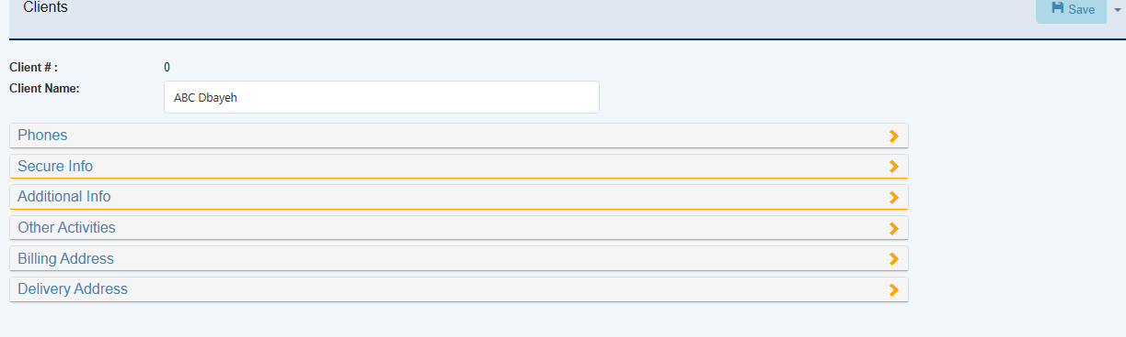
- What is this in the phones tab.. the second icon is for what

- When is the validation of fields done… when you go out from the field.. when you save? When you leave a section for another?
As I was not able to save I opened each section…
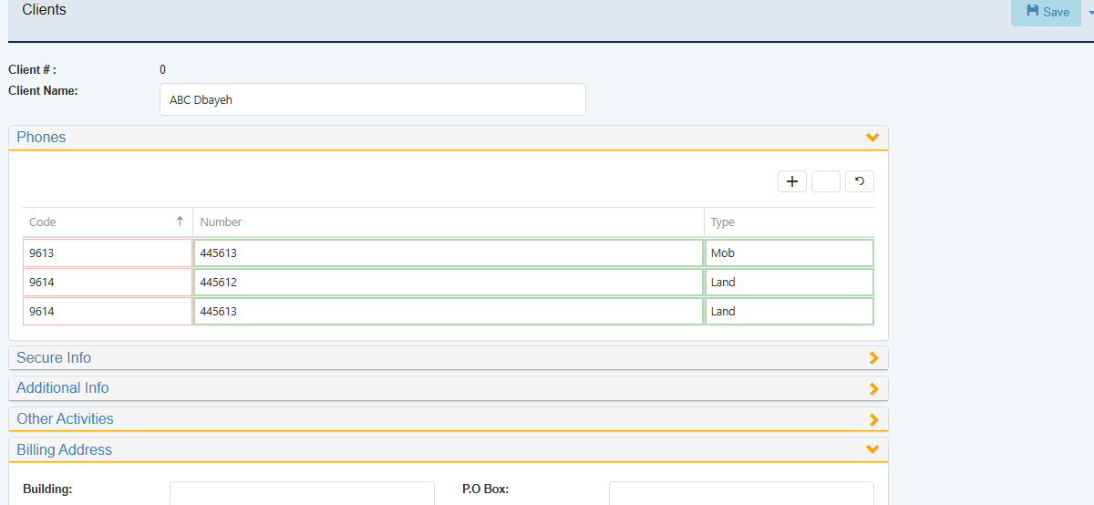
when I clicked on code I got this message..
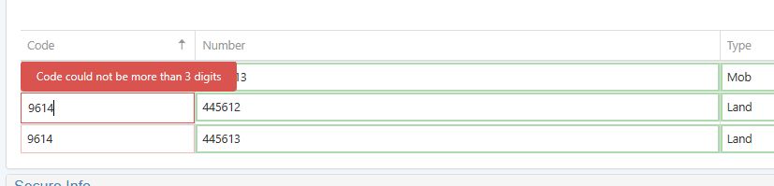
- Now when I save it opens the section of additional info to show ! on main activity.. I fill it,. Then save.. it shows the country.. try to save after.. it doesn’t.. I open again the sections to see that default currency in secure info tab is red…

- I think there should be a way for the eye to know directly the mandatory fields…

- cost center mandatory for a clent from cmp job costing param not followed

- User cost center security not followed.. .i have added for dolly user only to see 1 cost center.. in job costing arde in client screen the help of cost centers shows only that cost center where as in web I can see all and save

