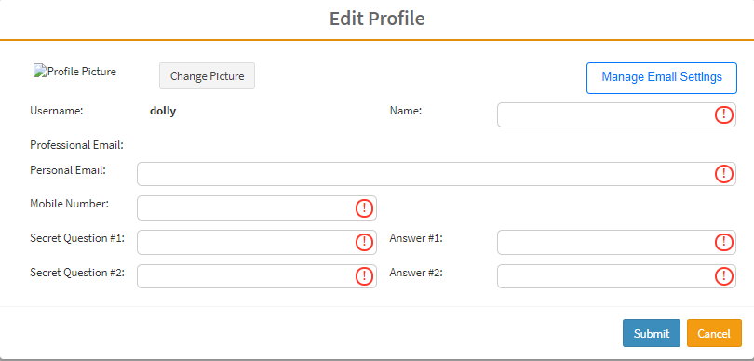

- I tried to change the picture but it was not loading..
- Is this screen reading from the profile of the employee linked to the signed in user?
- Professional mail… no field to enter it… and if it s reading from the employee. Then why it s not coming…

