Default users to database

When u put the database name (should be empty whem you open the add new screen so the error shows), click on set default database it removes the click on set default database and u have to click it another time to work

Notice below the database name and warning on another database
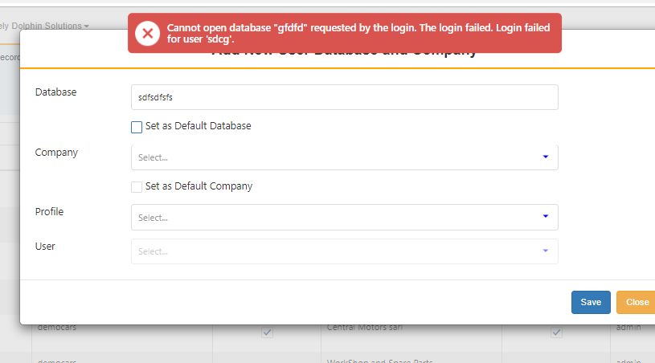

Put a real database then empty it and choose any non existing one… it will skip the database normally without any warning that data does not exist..

Sometimes it gets another error that is invalid object name jjj.sdcomp

